Holt

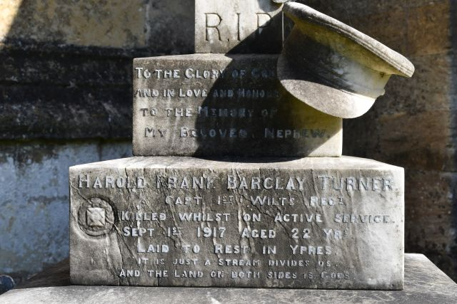
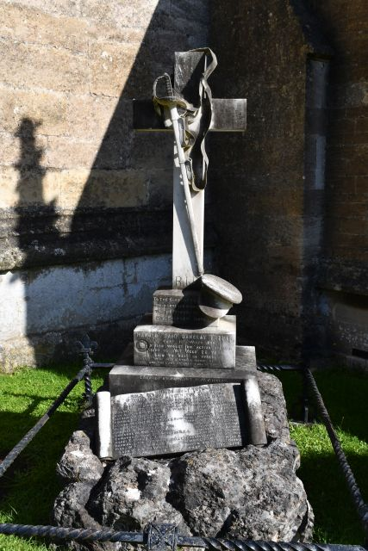

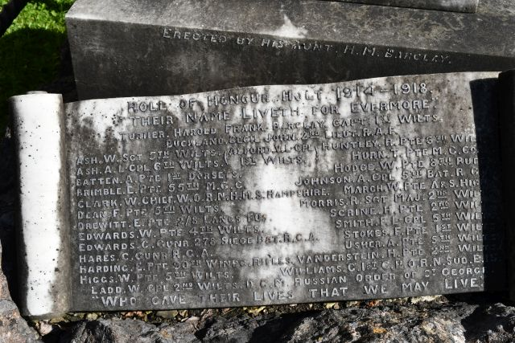

To the Glory of God
And In Love and Honour
To the Memory of
My Beloved Nephew.
Harold Frank Barclay Turner.
Capt. 1st Wilts Regt.
Killed whilst on Active Service.
Sept 1st 1917 Aged 22 Yrs.
Laid To Rest In Ypres.
"IT Is Just A Stream Divides Us.
And the land on both sides is God's".

Erected by his Aunt, H.M. Barclay.
Roll of Honour Holt 1914 ~ 1918
Their Name Liveth for Evermore

Turner, Harold Frank Barclay, Capt, 1st Wilts.
Buckland, Cecil John, 2nd Lieut. R.A,F,

Surname | Given Names | Rank | Regiment | Notes
Alford | V.L. | Cpl. | 1st Wilts.
Ash | W. | Sgt. | 5th Wilts.
Ash | A. | L-Cpl. | 6th Wilts.
Batten | A. | Pte. | 1st Dorsets
Brimble | E. | Pte. | 55th M.G.C.
Clark | W. | Chief W.O. | R.N. | H.M.S. Hampshire
Dean | F. | Pte. | 5th Wilts.
Drewett | E. | Pte. | 2/8 Lancs Fus.
Edwards | W. | Pte. | 4th Wilts.
Edwards | C. | Gunr. | R.G.A. | 278 Siege Bat.
Hares | C. | Gunr. | R.G.A.
Harding | E. | Pte. | 90th Winpg. Rifles
Higgs | W. | Pte. | 5th Wilts.
Ladd | W. | Cpl | 2nd Wilts. | #
Huntley | R. | Pte. | 6th Wilts.
Hurn | T. | Pte. | M.G. Corps.
Hodge | W. | Pte. | 8th Buffs
Johnson | A. | Cpl | 5th Bat. R.G.A.
March | W. | Pte. | A & S Highs.
Morris | R. | Maj. | 2nd Wilts.
Scrine | H. | Pte. | 2nd Wilts.
Smith | F.L. | Cpl. | 5th Wilts.
Stokes | F. | Pte. | 1st Wilts.
Usher | A. | Pte. | 5th Wilts.
Vanderstein | H. | Pte. | 2nd Wilts.
Williams | G. | 1st C.P.O. | R.N. | Sub. E. 15

# LADD, William Herbert, Distinguished Conduct Medal (D.C.M.), Russian Order of St. George

“Who Gave Their Lives That We May Live.”

