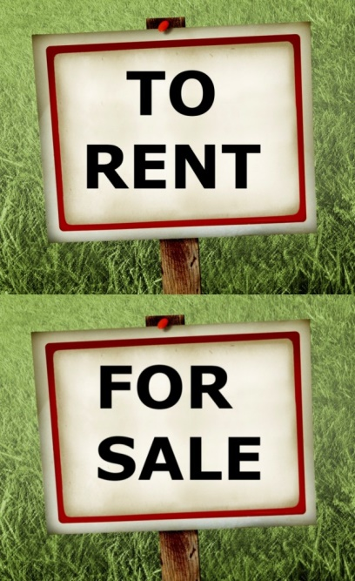
PROPERTY
Matters

Parish
Year Range

