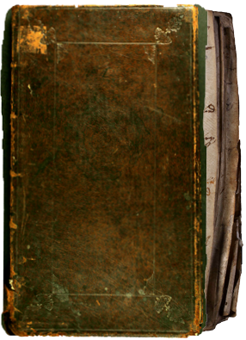

Extracts from Tockenham
Parish Register
1714

A Particular of ye bounds of the Churchyard of the Parish of Tokenham by where the same ought to be made ye required
From the roade on ye Southside to the Parsonage Court yard belongs to Kilberies those adjoyning all that streight hedg on the South Side of the Church belongs to ye Parsonage.
From ye corner next ye Parsonage pond One hundred & sixteene foold & half formerly belonged to ye sev[era]ll tenants in ye possession of Booth Coles Church &c. all of them now in ye possession of M. Smith.
Next that to ye Corner Sixteen foold & half Humpy. Butcher from ye Corner to ye Church and gate eight foold for in del ye Booths now Mr. Smiths.
The Gate & posts belong to ye Parish in generall from ye gate on ye right hand twenty seven foold belongs to Sayes now Mr. Knightons from the said to ye corner conteynings one hundred & fouer foold & likewise beyond the corner twenty Six foold & a halfe belongs Mr Wallis's farm from the said forty five foot to Mr. Smith's lands at [Sh..] from the said Seven foot to Francis Newman from the said to ye roade belongs to ye Parish in gen[era]ll
This is an attempt ye have formerly seen and under ye hand writing of Theophilus Quintin Clerk who was rector of this parish many years was againe examined & agreed unto by Mr Barkley late Rector of this parish Edwards death then Parish Clark & my Selfe and attested under our severall hands as this is under mine this twenty seventh day of Sept 1714

Signed M. Smith
Witness hereunto by John Brinsden, Rector and John Taylor, Clark

OPC note: John Brinsden, Rector 1712–1745
Mr. Matthew Smith, esq., died 1733/34.
John Taylor died 1737.

Source: Tockenham St. Giles Parish Register 1653-1766

