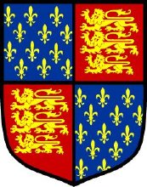
Tax List 1332
On 10th September 1332 parliament granted Edward III a fifteenth and a tenth of the movable goods of the laity of the realm. Those with movable goods in cities and boroughs and on ancient demesne of the Crown were to contribute the tenth, others the fifteenth.
Two assessors were and collectors were appointed for the county on 16th September 1332. The Wiltshire list was compiled during the winter of 1332-1333 and handed to the Exchequer on 23rd February 1333.
The table below shows the assessed taxes for the parish, borough or village.

(Place of Assessment)

Surnames | Forenames | Tax Amount
Surnames | Forenames | s | d
Total Proved

