Probate
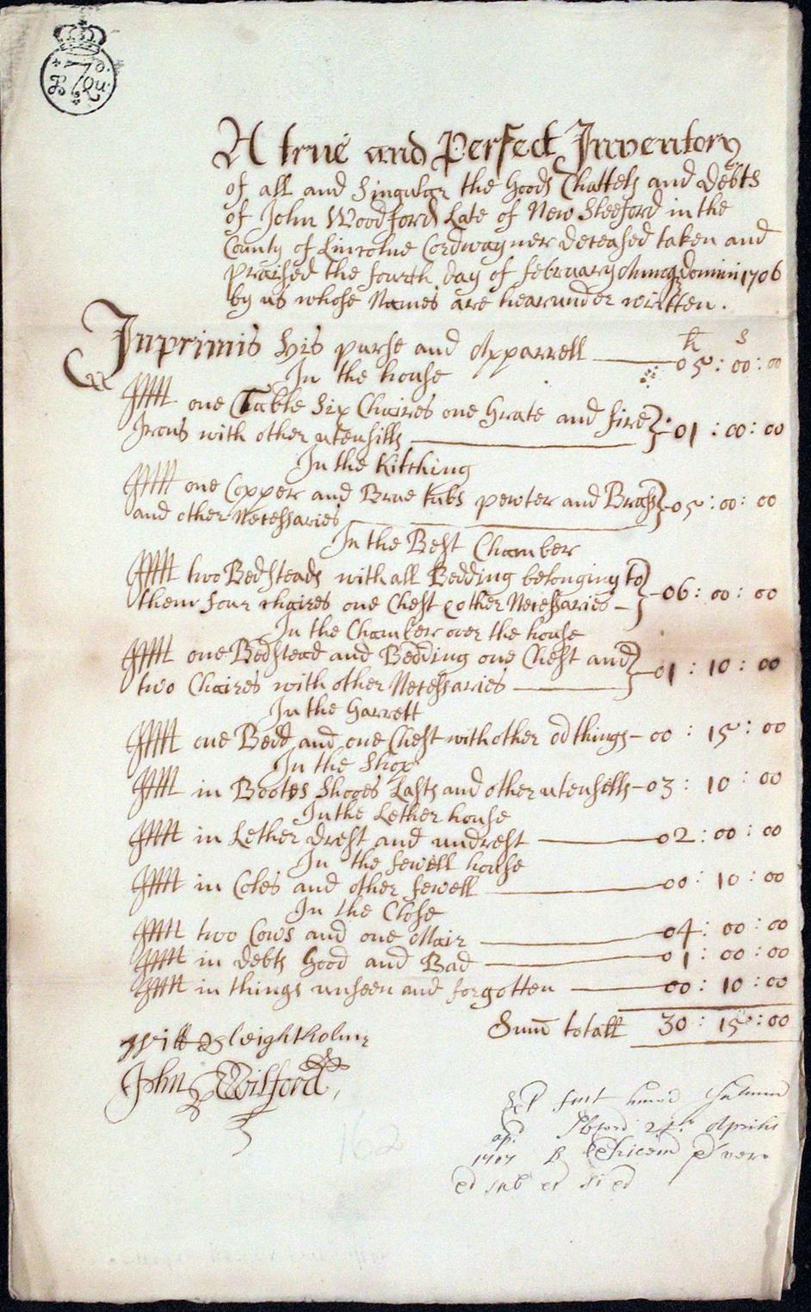
Inventory

(Body of Inventory Here)

(Signatures of Appraisers Here)

