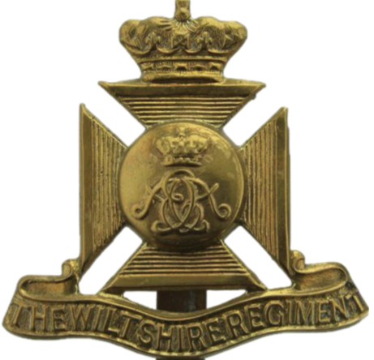

WWI Casualty

Stewart Richard Stevens

Surname |  | Given Names |  | Rank |  |  | Number | Regiment |  |  | Attachment |  |  | Date of Death |  |  | Age at Death
 |  |  |  |  |  |  |  |  |  |  |  |  |  | Year |  | Date | Age at Death
Stevens |  | Stewart Richard |  | Private |  |  | 23631 | Wiltshire Regiment |  |  | 1st Bn. |  |  | 1916 |  | 7 July | 27
Date of Birth |  |  | Place of Birth |  | Father |  |  |  | Mother |  |  | Baptised
Year | Date |  |  |  | Surname | Given Names |  |  | Maiden Name | Given Names |  | Year | Date |  | Place
1889 |  |  | Fonthill Gifford |  | Stevens | Alfred |  |  | Aitkin | Lucy Stewart

Census Information
Year | Surname | Given Names | Status | Age | Occupation | Place of Birth | Relationship to Head
Chicklade St., Chicklade, Wiltshire
1891 | Stevens | Alfred | Married | 26 | Carpenter | Fonthill Gifford, Wilts.
 | Stevens | Lucy S. | Married | 24 |  | Park St, Grosvenor Sqr, Ldn. | Wife
 | Stevens | Stewart R. |  | 2 |  | Fonthill Gifford | Son
 | Stevens | Florence A. |  | 5m |  | Chicklade, Wilts. | Daughter
Chapel House, Fonthill Gifford
1901 | Stevens | Alfred | Married | 36 | Carpenter | Fonthill Gifford, Wilts.
 | Stevens | Lucy S. | Married | 34 |  | Park St, Grosvenor Sqr, Ldn. | Wife
 | Stevens | Stewart R. |  | 12 |  | Fonthill Gifford | Son
 | Stevens | Florence A. |  | 10 |  | Chicklade, Wilts. | Daughter
 | Stevens | Archibald A. |  | 8 |  | Chicklade | Son
 | Stevens | Douglas L. |  | 7 |  | Chicklade | Son
 | Stevens | Frederick C. |  | 5 |  | Berwick St. Leonard, Wilts. | Son
 | Stevens | Mabel A. |  | 3 |  | Berwick St. Leonard | Daughter
 | Stevens | Albert |  | 1 |  | Berwick St. Leonard | Son
 | Stevens | Herbert E. |  | 2m |  | Fonthill Gifford | Son
Chapel House, Hindon, Wilts.
1911 | Stevens | Alfred | Married | 45 | Carpenter on Estate | Fonthill Gifford | [died 1918]
 | Stevens | Lucy | Married | 44 |  | Grosvenor Sq., London | Wife
 | Stevens | Stewart Richard | Single | 22 | House Painter | Fonthill Gifford | Son
 | Stevens | Archibald Alfred | Single | 18 | House Painter | Chicklade | Son
 | Stevens | Douglas Louis E. | Single | 17 | Shoemaker | Chicklade | Son
 | Stevens | Fred Charles E. | Single | 15 | Garden Boy | Chicklade | Son
 | Stevens | Mabel Alice V. |  | 13 | School | Berwick St. Leonard | Daughter
 | Stevens | Sidney A. V. |  | 11 | School | Berwick St. Leonard | Son
 | Stevens | Herbert Ed. |  | 10 | School | Fonthill Gifford | Son
 | Stevens | Dorothy K. |  | 7 |  | Fonthill Gifford | Daughter
 | Stevens | Lucy Beatrice |  | 5 |  | Fonthill Gifford | Daughter
 | Stevens | Francis Osman |  | 3 |  | Fonthill Gifford | Son
 | Stevens | Winifred L. |  | 2 |  | Fonthill Gifford | Daughter
 | Stevens | Mary Margery |  | 8m |  | Fonthill Gifford | Daughter

Military Service Record
Enlistment Details
Year |  | Date |  |  |  | Place |  |  |  | Age |  |  |  |  | Trade |  |  |  |  |  |  | Religion
 |  |  |  |  |  |  |  |  |  | Years | Months |  |  | Days
Physical Description
Height |  |  |  |  |  |  | Complexion |  |  |  |  |  | Eye Colour |  |  |  |  | Hair Colour | Distinguishing Marks
Feet |  |  | Inches
Next of Kin
Surname |  |  |  | Given Names |  |  |  | Status |  |  |  | Relationship |  |  |  |  | Abode
Stevens |  |  |  | Lucy S. |  |  |  | Widow |  |  |  | Mother
Details of Death
Date of Death |  |  |  |  | Cause of Death |  |  |  | Theatre of War |  |  |  |  |  |  | Ships Name |  |  |  | War Gratuity Paid
Year | Date |  |  |  |  |  |  |  |  |  |  |  |  |  |  |  |  |  |  | Year |  |  | Date | £ |  |  | s. | d.
1916 | 7 July |  |  |  | Died of Wounds |  |  |  | Western European |  |  |  |  |  |  |  |  |  |  | 1919 |  |  |  | 3 |  |  | 0 | 0
Grave Location
Cemetery |  |  |  |  |  |  |  |  |  |  |  |  |  |  |  |  |  |  | Plot Number
Puchevillers British Cemetery, France |  |  |  |  |  |  |  |  |  |  |  |  |  |  |  |  |  |  | I.D.41.

War Memorials and Commemorations
Memorial Name and Location | Panel Number
Hindon War Memorial, Wilts.
Other Significant Information
Parents were married on 4 October 1888 at All Saints Church, Chicklade, Wiltshire. Lucy signed herself as Aitkin.

