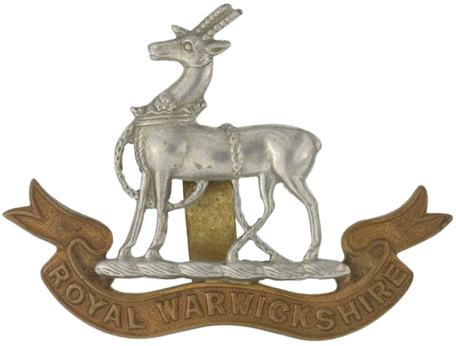

WWI Casualty

Lewis Vincent

Surname |  | Given Names |  | Rank |  |  | Number | Regiment |  |  | Attachment |  |  | Date of Death |  |  | Age at Death
 |  |  |  |  |  |  |  |  |  |  |  |  |  | Year |  | Date | Age at Death
Vincent |  | Lewis |  | Private |  |  | 28602 | Royal Warwickshire Regiment |  |  | 16th Bn. |  |  | 1918 |  | 14 Nov
Date of Birth |  |  | Place of Birth |  | Father |  |  |  | Mother |  |  | Baptised
Year | Date |  |  |  | Surname | Given Names |  |  | Maiden Name | Given Names |  | Year | Date |  | Place
1884 |  |  | Hindon, Wilts. |  | Vincent | John |  |  | Dukes | Maria

Census Information
Year | Surname | Given Names | Status | Age | Occupation | Place of Birth | Relationship to Head
Hawking Down, Hindon
1891 | Vincent | John | Married | 47 | Agricultural Labourer | Hindon
 | Vincent | Maria | Married | 37 |  | Hindon | Wife
 | Vincent | Lizzie |  | 12 | Scholar | Hindon | Daughter
 | Vincent | Louis |  | 6 | Scholar | Hindon | Son
 | Vincent | Leonard |  | 4 | Scholar | Hindon | Son
 | Vincent | Frances |  | 1m |  | Hindon | Daughter
Hawking Down, Hindon
1901 | Vincent | John | Married | 56 | Carter on Farm | Fonthill Gifford, Wilts.
 | Vincent | Maria | Married | 44 |  | Hindon | Wife
 | Vincent | Elizabeth | Single | 23 | General Servant, Dom. | Hindon | Daughter
 | Vincent | Louis | Single | 17 | Under Carter on Farm | Hindon | Son
 | Vincent | Leonard |  | 14 | … on Farm | Hindon | Son
 | Vincent | Elsie |  | 10 |  | Hindon | Daughter
 | Vincent | Alice |  | 6 |  | Hindon | Daughter
High Street, Hindon
1911 | Vincent | John | Married | 66 | Farm Labourer | Fonthill Gifford | Wife
 | Vincent | Maria | Married | 56 |  | Hindon | Son
 | Vincent | Louis | Single | 28 | Farm Labourer | Hindon | Son
 | Vincent | Leonard | Single | 22 | Waggoner on Farm | Hindon | Daughter
 | Vincent | Alice | Single | 16 |  | Hindon | Daughter

Military Service Record
Enlistment Details
Year |  | Date |  |  |  | Place |  |  |  | Age |  |  |  |  | Trade |  |  |  |  |  |  |  | Religion
 |  |  |  |  |  |  |  |  |  | Years | Months |  |  | Days
Physical Description
Height |  |  |  |  |  |  | Complexion |  |  |  |  |  | Eye Colour |  |  |  |  | Hair Colour | Distinguishing Marks
Feet |  |  | Inches
Next of Kin (Sole)
Surname |  |  |  | Given Names |  |  |  | Status |  |  |  | Relationship |  |  |  |  | Abode
Vincent |  |  |  | Maria |  |  |  |  |  |  |  | Mother
Details of Death
Date of Death |  |  |  |  | Cause of Death |  |  |  | Theatre of War |  |  |  |  |  |  | Ships Name |  |  |  |  | War Gratuity Paid
Year | Date |  |  |  |  |  |  |  |  |  |  |  |  |  |  |  |  |  |  |  | Year |  |  | Date | £ |  |  | s. | d.
1918 | 14 Nov |  |  |  | Died of Wounds |  |  |  | Western European |  |  |  |  |  |  |  |  |  |  |  |  |  |  |  | 15 |  |  | 0 | 0
Grave Location
Cemetery |  |  |  |  |  |  |  |  |  |  |  |  |  |  |  |  |  |  |  | Plot Number
Mont Huon Military Cemetery, Le Treport, France |  |  |  |  |  |  |  |  |  |  |  |  |  |  |  |  |  |  |  | X.B.13A.

War Memorials and Commemorations
Memorial Name and Location | Panel Number
Hindon War Memorial, Wilts.
Other Significant Information
Lewis Vincent enlisted at Devizes, Wiltshire with Royal Warwickshire Regiment. He was given the rank of Private & a service number of 28602.
John Vincent & Maria Dukes had Banns of Marriage December 1877. They had a son Lewis who was baptised 8 Jan 1882 at Hindon, and was buried 18 April 1883 at Hindon, aged 1 year.
James Vincent & Alice Hacker were married at Hindon 26 March 1878.
The 1881 census shows that James & Alice [buried 1 Aug 1885 at Hindon] lived at Vincent's Buildings , Fonthill Gifford. Children were Frederick, Lucy. All were born at Fonthill Gifford.
James Vincent and Mary Wilkins were married June Qtr 1886.
Hindon St. John the Baptist (Baptisms)

25 Aug 1878 Frederic James Vincent s/o James & Alice
7 Sep 1879 Elizabeth Jane d/o John & Maria
14 Mar 1880 Lucy d/o James & Maria
8 Jan 1882 Lewis s/o John & Maria
13 Aug 1882 Ellen d/o James & Alice
27 July 1884 Lewis s/o James & Alice

Hindon St. John the Baptist (Burials)

18 Apr 1883 Lewis, aged 1 year
1 Aug 1885 Alice, aged 34 years
15 Jun 1889 Herbert Allen, aged 1 year of Hawking Down

